KS2 Long Term Coverage Plan
Links to:  - Progression maps  - Subject-specific coverage maps  - External schemes | Cycle A |  |  | Cycle B
 | Autumn  Adventurers and Explorers | Spring  Oh! What A Wonderful World! | Summer  Who Has the Power? | Autumn  Let Us Remember | Spring  Amazing Places and Spaces | Summer  Who Do You Think You Are?
English  Sounds-Write  Sounds-Write  Talk for Writing  Writing progression map  Reading progression map  English Whole-School Plan | Story Pattern: Traditional tale  Model Text: Cinderella  Children rewrite and reimagine a classic fairy tale. They will focus on developing character.  Text type: Biographies  Children write a biography based on the life of one of the 5 monarchs from our history unit.  Class  Text: Journey  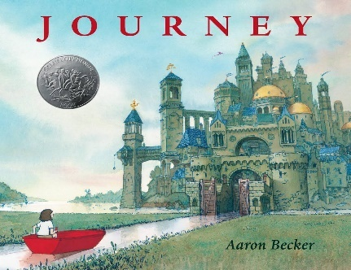  Text type: Portal / Adventure story  Children will write their own adventures stories, inspired by the picture book: Journey. | Non-fiction Text Type: Information text  Model Text: The Cumbrian Ridge-Back  Pupil’s will take the role of dragon seekers and write their own information texts detailing their own imagined dragon.  Story Pattern: Suspense Story  Text: The Manor House  Children will build suspenseful stories focusing on: personifying the setting to make it sound dangerous; showing the character’s feelings through their reactions; intensifying the situation through repetition and using dramatic adverbials to add pace and drama.  Non-fiction Text Type: Discussion  Text: Is Plastic Fantastic?  Class text: A Planet Full of Plastic, by Neal Layton  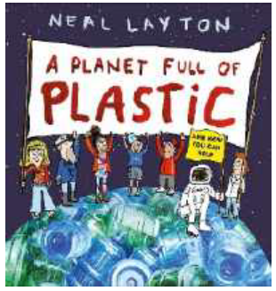  Pupils will learn and apply the strategies for building a balanced argument. | Non-Fiction Text Type: Retrospective Recount (KS2 Residential)  Pupils will recall their latest residential in the style of a recount.  Text type: Wishing Story  Text: Thief by Malorie Jackson  Model text: The Catch  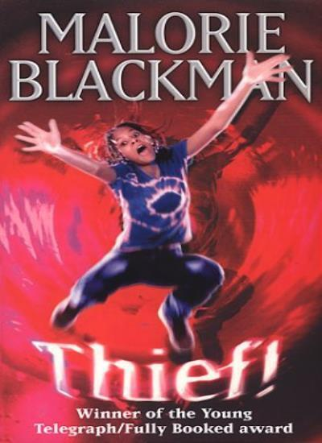  Pupils will explore way that action can be explored through a character’s  internal voice, their thoughts, what they say, as well as what they do.  Text Type: Warning Story  Class text (short story): The Caravan by Pie Corbett  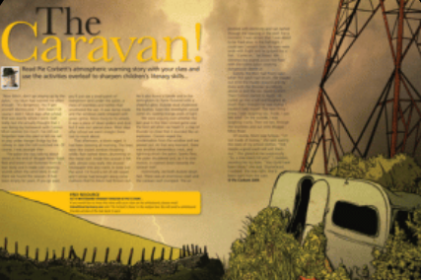  Model Text: The Railway Tracks  Pupils will write a warning story with a focus on developing dialogue in their narratives. | Story Pattern: Change Story  Pupils will focus on beginnings and endings as they construct a narrative highlighting the changes their characters go through.  Class Text: After the War  Non-Fiction Text Type: Persuasion  Model Text: Visit Greece  Pupils will develop their persuasive writing skills. Linking to their Geography project, pupils will summon all the elements of persuasion to convince their reader to travel to a destination of their choice by creating exciting leaflets, brochures or adverts.  500-word story: Our pupils will take part in the national 500-word story writing competition. | Non-Fiction Text Type: Explanation Model Text (Why do rivers matter?)  Text: River Story  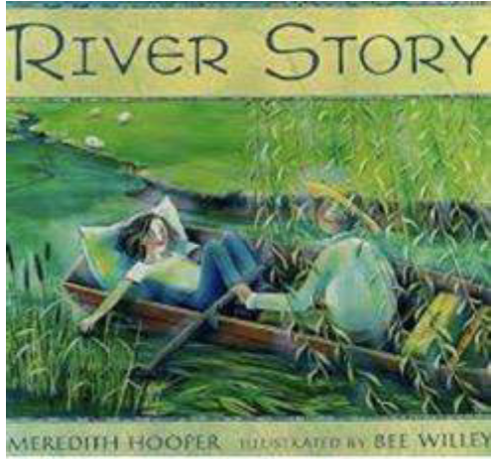  Pupils will develop their explanation writing skills.  Text Type: Meeting Story  Class Text: The Midnight Fox  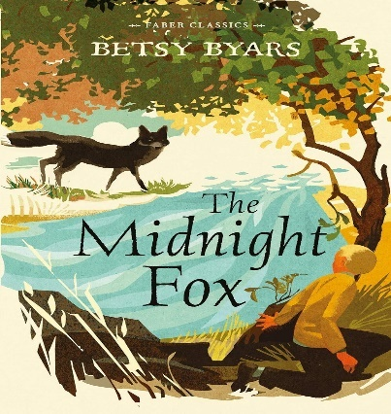  Pupils will write their own meeting tales. Older pupils will be challenged to innovate on the standard underlying pattern (for example, by beginning the story with a flashback). Their major foci will be action and dialogue | Story Pattern: Finding Tale  Class Text: Fly, Eagle, Fly  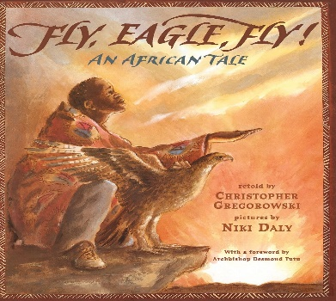  Pupils will focus on description as they bring to life the world their character travels to.  Text Type: Journey Story  Class Text: The Eagle of the Ninth, by Rosemary Sutcliffe  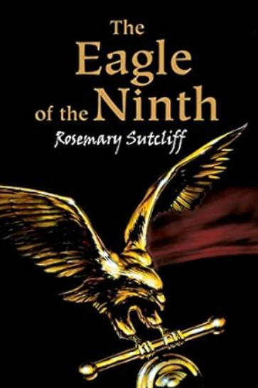  Taking inspiration from our class text, pupils will write a journey story set in a Roman site from the local area (Hadrian’s Wall). Developing character through dialogue will be the key focus.  Non-Fiction Text Type: Instruction Writing  Model text: How to look after a pet dragon  Pupils will write instructions based on caring for or training an imaginary creature.
Maths  White Rose Maths  Maths progression map | Number and Place Value  Four operations  Area and Perimeter | Fractions  Decimals  Percentages (Years 5 and 6)  3,4 and 8 times tables (Year 3)  6, 7, 9, 11 and 12 times tables (Year 4) | Geometry  Statistics  Measurement  Algebra (Year 6)  Ratio and Proportion (Year 6) | Number and Place Value  Four operations  Area and Perimeter | Fractions  Decimals  Percentages (Years 5 and 6)  3,4 and 8 times tables (Year 3)  6, 7, 9, 11 and 12 times tables (Year 4) | Geometry  Statistics  Measurement  Algebra (Year 6)  Ratio and Proportion (Year 6)
History  CUSP  History progression map | 5 Monarchs  Children will learn about 5 major kings and queens from 1066 to the 20TH century | Vikings  Children will explore what life was like for the Vikings and how the landscape of Scandinavia motivated them to invade Britain. They will learn when and where the Vikings invaded. We will explain, using evidence, why the Vikings were feared and successful. They will sequence the battles and outcomes across time that led to the formation of ‘Danelaw’ - the land of the Vikings in Britain. | Revisit and Review  Stone Age to Iron Age  Pupils will retrieve and remember the changes that happened between: the three ages of the Stone Age, the Bronze Age; and the Iron Age. | Local Study  Through making connections with our local community, pupils will learn about how conflict changed our local area during WWII. They will study primary sources of evidence and discover the key role the local area played in the conflict. | Egypt  Pupils will find out who the ancient Egyptians were, where they lived and how they used the River Nile. Pupils will discover the varied achievements of the old, middle and new kingdoms. Pupils will study evidence to find out what the ancient Egyptians wrote. After visiting an Egyptian museum, pupils will bring their learning together and transform the classroom into their own Egyptian museum! | Romans  Pupils will discover who the Romans were and what life was like in ancient Rome. They will visit local Roman forts to discover more about the Roman invasion and occupation of Britain – when it started and how and why it ended. Finally, they will gain an understanding of the technological changes that occurred under Roman rule and answer the question: How did Britain change under Roman rule?
Geography  CUSP  Geography progression map  Geography Vocabulary | World Countries and biomes  Pupils will use their mapping skills – both physical and digital – to locate the world’s countries with a focus on Europe; North and South America; and the different environmental biomes of the world. They will identify key human and physical features of these locations. | Earthquakes, Mountains and Volcanoes  Pupils will construct and explode their own crafted volcanoes based on one of the four types of volcano: shield, fissure, stratovolcano and caldera. They will learn that the Earth is formed of 4 layers from the inner core to the crust. They will explore the causes of earthquakes. They will understand how mountains are formed. | Fieldwork and Map Skills  Year 3 and 4  Pupils learn to use OS maps and will learn how scale changes the way we describe a place. They will apply their fieldwork skills to the area just beyond the school.  Years 5 and 6  Four and Six Figure Grid References  Pupils will understand what 4 and 6 figure grid references are. They will describe locations, landmarks and places as a geographer would. They will discover why we need latitude and longitude. | Comparison study: Lake District, Tatra Mountains, Caribbean  Pupils will compare and contrast the human and physical features of three varied locations. They will learn how orogeny helped to form the Lake District. They will persuade potential tourists to visit Jamaica and they will understand how the physical Geography of Poland – specifically the Tatra Mountains – influences patterns of trade, tourism and settlements. | Rivers  Pupils will learn about the many features of a river – from V-shaped valleys to oxbow lakes. They will conduct a field study of Caldbeck’s local rivers and apply their mapping skills to discover where the river’s source and mouth are. | Latitude and Longitude  Pupils will find out what latitude and longitude are. They will discover how to find exact locations around the world. They will learn about time zones and how the anti- clockwise rotation of the Earth determines whether it’s day or night.
Science  CUSP  Science progression map | Year 3 and 4  Light  Pupils will explore how shadows are formed and how they change size when an object moves closer to, or further away from a light source. Pupils will gain an understanding of which things are and aren’t light sources  States of Matter  Pupils will investigate melting, evaporating and condensing. They will be introduced to three states of matter: solid, liquids and gases.  Year 5 and 6  Earth and Space  Pupils will learn about the 8 planets of the solar system and some of their special features. They will learn how our view of the moon changes within a lunar month. They will find out why the Earth’s tilt causes our seasons and how the rotation of the Earth causes day and night. | Year 3 and 4  Teeth  Pupils will discover the different types of teeth humans have and their roles in the digestive system. They will learn about the parts of the digestive system and understand how the process of digestion works.  Plants  Pupils will understand the roles of different parts of a plant. They will discover that leaves make food for the plant. They will find out how water moves through a plant; the role of flowers; and gain an initial understanding of pollination.  Year 5 and 6  Living things and their habitats  Pupils will compare the life cycles of birds, mammals, amphibians and insects. They will classify animals into broad groups and give reasons for these classifications. They will understand how plants and animals reproduce. | Year 3/4  Forces and magnets  Pupils will investigate how magnets attract and repel. They will investigate contact and non-contact forces and how surfaces affect the motion of an object. They will conduct experiments to sort materials into magnetic and non-magnetic.  Year 5 and 6  Forces  Pupils will conduct investigations to find the effect of air and water resistance. They will observe situations where friction can be helpful and when it is not. They will find out when levers, pulleys and gears – which they are familiar with from their Design and Technology work – can be helpful to us.  Year 5 and 6  Electricity  Pupils will represent and build a series circuit and understand the components that make it work. They will test how the number of cells and voltage affects the components in a circuit. | Year 3/4  Sound  Pupils will be introduced to what sound is and how it travels. They will conduct experiments to test how different materials can be used to soundproof a studio. They will understand the concepts of ‘pitch’ and ‘loudness’,  Year 5 and 6  Animals and humans  Pupils will learn about the heart and how it functions. They will understand how nutrients are transported around the body. They will conduct experiments to measure the impact of exercise on heart rate. They will explain what we can do to keep our circulatory system healthy.  Animals and humans – Water transportation  Pupils will learn where the kidneys are, what they do and how they keep us healthy. | Year 3/4  Rocks  Pupils will understand what types of rocks there are and how they are formed. They will test rocks to find out if they are limestone or chalk. They will investigate the properties of soil and will discover how fossils are formed through studying the life of Mary Anning.  Year 5 and 6  Properties and changes of materials  Pupils will investigate reversible and irreversible changes. They will explore the differences between solutions and mixtures. They will investigate the properties of materials. | Year 3/4  Living thing and their habitats  Pupils will understand the characteristics of living things. They will observe which animals are vertebrates and which are invertebrates. They will classify plants, use classification keys and predict what will happen if a habitat changes.  Year 5 and 6  Evolution and inheritance  Pupils will investigate how life has evolved over time. They will extract DNA from a strawberry. They will study the work of Darwin and Wallace and the arguments they put forward for evolution.  Animals and humans  Pupils will describe the changes as humans develop to old age. They will understand the human timeline and discover more about the adolescent stage. They will compare human and animal lifespans and gestation periods.
Music  Charanga  Music progression map  Music Vocabulary | Let Your Spirit Fly  Singing for the Fellview Christmas Performance | Glockenspiel (1)  I wanna play in a band | Singing for the Fellview Summer Performance  Lean On Me | Round and Round  Preparing for Christmas Performance | Your Imagination  Zootime | Friendship Song  Preparing for Summer Performance
D&T  Projects on a Page  D&T progression map  Food Technology  Phunky Foods | Years 3 and 4  Levers and Linkages  Pupils will design, make and evaluate a Christmas card using levers and linkages. They will use exploded diagrams to plan their designs identifying features including: Levers, Linkages, Loose pivots, Fixed pivot,  Guide bridge, Input, Output and Slot  Years 5 and 6  Levers and Linkages  As above, but with additional focus on linear, reciprocating and oscillating movement | Years 5 and 6  Mechanical Systems - Pulleys or gears  Pupils will design, make and evaluate a racing car with moving parts including pulleys or gears. When complete, they will test their cars in races of speed and endurance.  Food Technology - Food for a Fiver  Pupils will plan, cost, budget for and produce a three-course meal for £5.00. They will describe the nutritional values of their meals. | Years 3 and 4 Mechanical Systems – Pneumatics  Pupils will design, make and evaluate a moving ‘creature in a box’ toy for small children using pneumatics. | Structures - Shell structures using computer-aided design  Pupils will design, make and evaluate CAD-based packaging to protect and display a food product for sale  Years 5 and 6  Computer-aided-design (CAD) in textiles  Pupils will design, make and evaluate a shopping bag for a relative using CAD | Years 3 and 4  Textiles - 2-D shape to 3-D product (sewing skills)  Pupils will design, make and evaluate a collar suitable for someone living in Ancient Egypt and display in the History Showcase this term. | Year 3/4 Electrical Systems  Simple circuits and switches  and Electrical Systems - Simple programming and control  Pupils will use crumble to program a simple, computer-controlled electric system to control incorporating switches, buzzers and bulbs.  Year 5/6 Electrical Systems  More complex switches and circuits  and Electrical Systems - Monitoring and control  Pupils will use Crumble to program, monitor and control a computer controlled electrical appliance.
PE  PE progression map | Running jumping Team games  Rugby  Football  Indoor athletics  Travelling with a ball  Striking a ball  Sports Leadership Skills Y5 and 6  Gymnastics | Throwing catching a ball  Team games  Netball  Dance O.A.A. and Orienteering  Multiskills  Table tennis | Tennis  Hockey  Rounders  Cricket  Local Tournaments e.g rounders,  Residential trips O.A.A e.g. climbing  Outdoor athletics  Sports Days (Year 5/6 Leading)  Swimming  Drama/Dance choreography for performance | Running jumping Team games  Rugby  Football  Indoor athletics  Travelling with a ball  Striking a ball  Sports Leadership Skills Y5 and 6  Gymnastics | Throwing catching a ball  Team games  Netball  Dance O.A.A. and Orienteering  Multiskills  Table tennis | Tennis  Hockey  Rounders  Cricket  Local Tournaments e.g. rounders,  City residential trip with wider PE opportunities  Outdoor athletics  Sports Days (Year 5/6 Leading)  Swimming  Drama/Dance choreography for performance
Art and Design  CUSP  Art and Design progression map | Drawing  Painting | Printmaking and Textiles  3D and Collage | Painting  Creative Response | Drawing  Painting | Printmaking  Textiles and Collage  3D | Painting  Creative Response
PSHE  Jigsaw  PSHE progression map | Being me in my world  Celebrating Differences | Dreams and Goals  Healthy Me | Relationships  Changing Me | Being me in my world  Celebrating Differences | Dreams and Goals  Healthy Me | Relationships  Changing Me
Computing  Knowsley CLC Computing  Computing progression map | Year 5/6  My Online Life  Children will further develop their knowledge of the risks of their online lives, including looking at online bullies, YouTube and how reliable information is online. | Year 3/4  My Online Life  Children will gain knowledge of the risks of their online lives and to develop skills when using online services.  KS2  Safer Internet Day activities  Internet safety session with our local PCSO | Year 3/4  Dancing Robot (Coding)  The children will explore computational thinking concepts and then they will focus on becoming independent programmers with the Scratch Jr app.  Year 5/6  Lost in Space (Coding)  Children will create a quiz program in Scratch. The children will learn about decomposition, algorithm flow charts, and creating programs with a variable.  KS2  Practical coding projects using MicroBit | Year 3/4  My Online Life  Pupils will learn how to manage their online reputation, build safe relationships and deal with online bullies. They will learn how to protect their online accounts and ensure technology doesn’t take over their lives.  Year 5/6  My Online Life  Pupils will learn how to make informed decisions online, secure their online accounts and analyse the reliability of online information.  Internet safety session with our local PCSO | Year 3/4  Real or Fake  Children will become aware of Fake News, giving them the skills to consider each piece of news they read on its own merits and decide what is real or fake.  Year 5/6  Youtuber  Children will learn about what being a ‘Youtuber’ actually means and they will explore the positive and negatives associated with being a YouTuber. The children are given the opportunity to create their own vlog, edit and then critique it and then look at online safety in this context. | Year 3/4  Keyboard Adventures (Typing Skills)  Pupils will be taught to improve their touch-typing and keyboard skills on both laptops and IPADS.  Year 5/6  VR Worlds  Pupils will learn about the concept of VR worlds and its applications. They will understand the concept of storyboarding and its importance in creating VR spaces. They will create an interactive VR space based on a planned written storyboard with different forms of media.
Languages  Twinkl Plannit French  Languages progression map | All Around Town / Let’s Visit a French Town  On the Move / This is France | Going Shopping – Let’s Go Shopping  Where in the World? /Our Precious Planet | What’s the Time?/ All in a Day  Holidays and Hobbies/ More to Explore | Getting to Know You/ Pleased to Meet You  All About Me/ All About Ourselves | Food, Glorious Food/ That’s Tasty  Family and Friends | Our School/ School Life  Time/ Time Travelling
RE  Jigsaw RE  RE at Fellview | Pupils will explore the following concepts and enquiry questions:  Concept: Islam  Does praying at regular intervals help a Muslim in their everyday lives? Concept: Humanism (short unit) What motivates Humanists to live a good life?  Concept: Christianity  Has Christmas lost its true meaning? | Pupils will explore the following concepts and enquiry questions:  Concept: Christianity  Could Jesus heal people? Did He perform miracles or was there some other explanation?  Concept: Christianity  What is 'good' about Good Friday? | Pupils will explore the following concepts and enquiry questions:  Concept: Islam  Does completing a pilgrimage make a person a better Muslim?  Concept: Hinduism (short unit)  Does visiting the Ganges make a person a better Sanatani (Hindu)? | Pupils will explore the following concepts and enquiry questions:  Concept: Buddhism  Is it possible for everyone to be happy? Concept: Other Worldviews Short unit exploring another worldview (e.g. Humanism) following children’s interests  Concept: Christianity  What is the most significant part of the nativity story for Christians today? | Pupils will explore the following concepts and enquiry questions:  Concept: Buddhism:  Can the Buddha’s teachings make the world a better place?  Concept: Christianity  Is forgiveness always possible for Christians? | Pupils will explore the following concepts and enquiry questions:  Concept: Christianity  Do people need to go to church to show they are Christians? OR Why are there four Gospels and how are they relevant for Christians?  Concept: Judaism (short unit)  Are Rosh Hashanah and Yom Kippur important to Jewish children?

